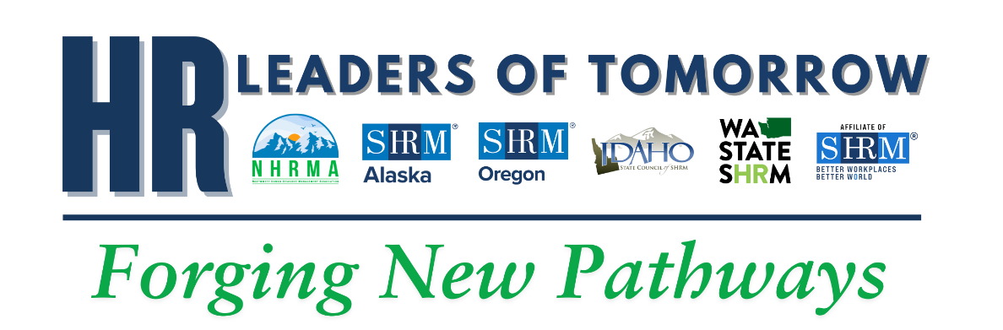

Friday, April 17, 2026
9:00am - Corporate Tours
Lunch on Own
2:00pm – Student Networking Activity
6:00pm - Welcome Reception

Saturday, April 18, 2025
8:15 am - Welcome and NHRMA Announcements
8:30am - Opening Keynote Address – Jenn Schwope (HR Director - Microsoft)
9:30am - HR Games: Round 1
Break
10:00am – General Session - Audrey Gacrcia (Seattle Children’s Hospital) &
Scott Washburn (VPHR Treetop)
Break
11:15am - Alumni Panel Discussion – Various CWU Alums
12:15pm HR Games: Round 2
12:30pm – Lunch
1:00pm - Chapter Leadership Session
Break
2:15pm - Concurrent Sessions – Chad Zimmerman (HR Director - Crunchpak) &
Tod Ayers (CHRO - Grant County PUD)
Break
3:30pm - HR Games: Round 3
4:00pm - HR Unscripted – Various HR Professionals
5:00pm - Final HR Games and Farewells

